**JISD Campus Registrar Appointment Request**

Jacqueline Danek

512-746-2188

[JHS (K-Z) Appointment Request](https://calendar.app.google/Pi6YqfBds3cEpj278)

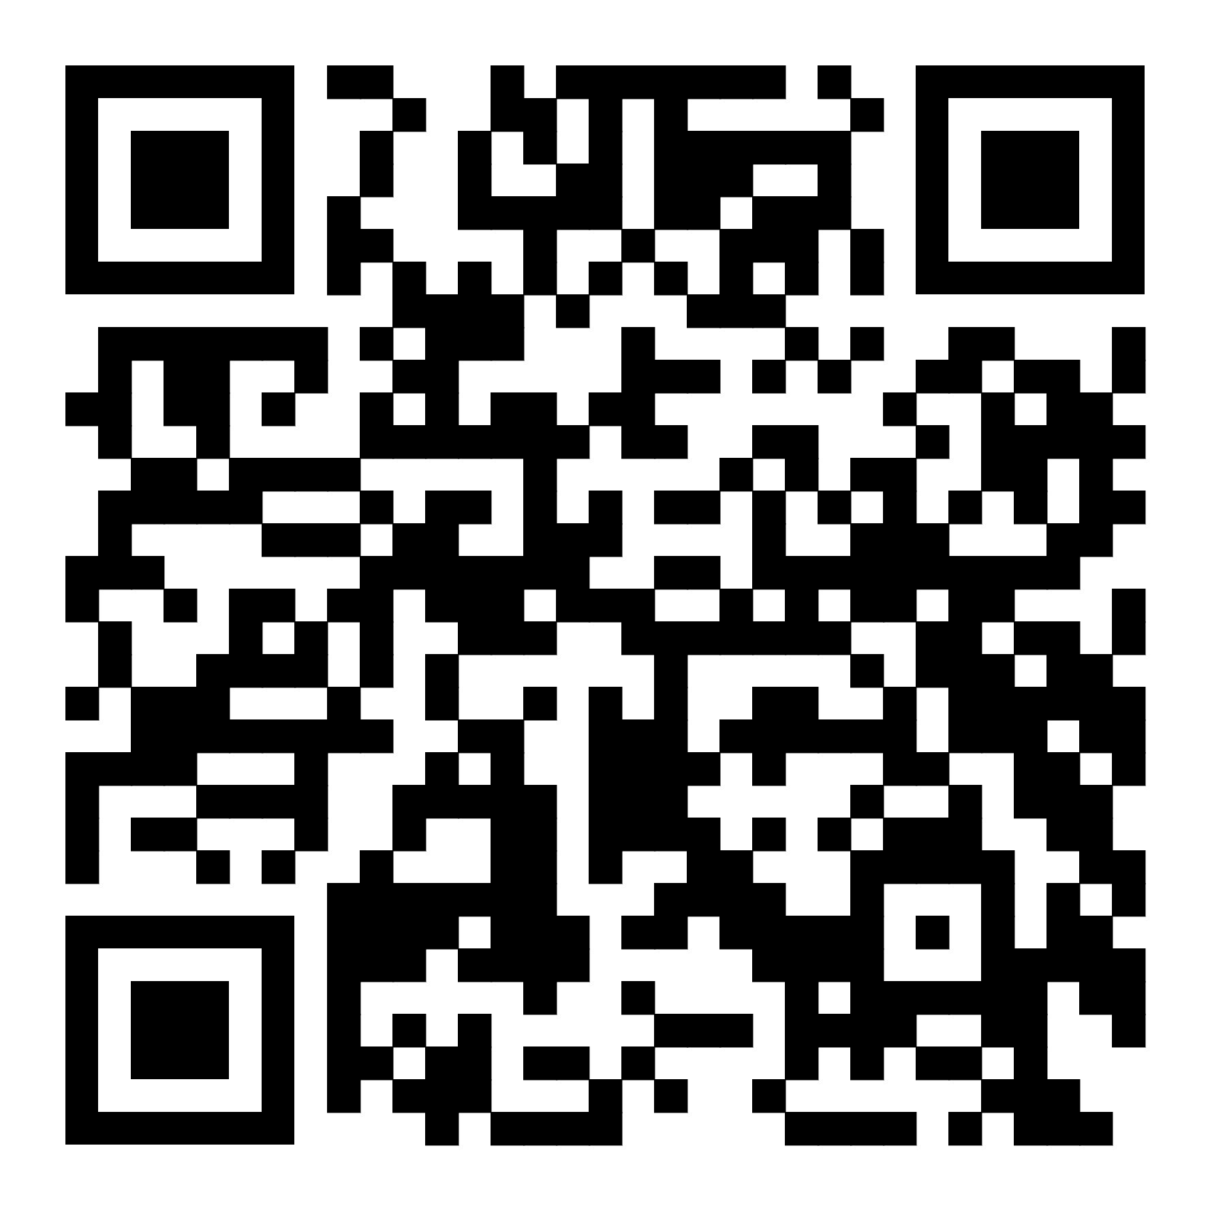

Angela Avalos

512-746-2188

[JHS (A-J) Appointment Request](https://calendar.app.google/hmS1p722UpGFoSi68)

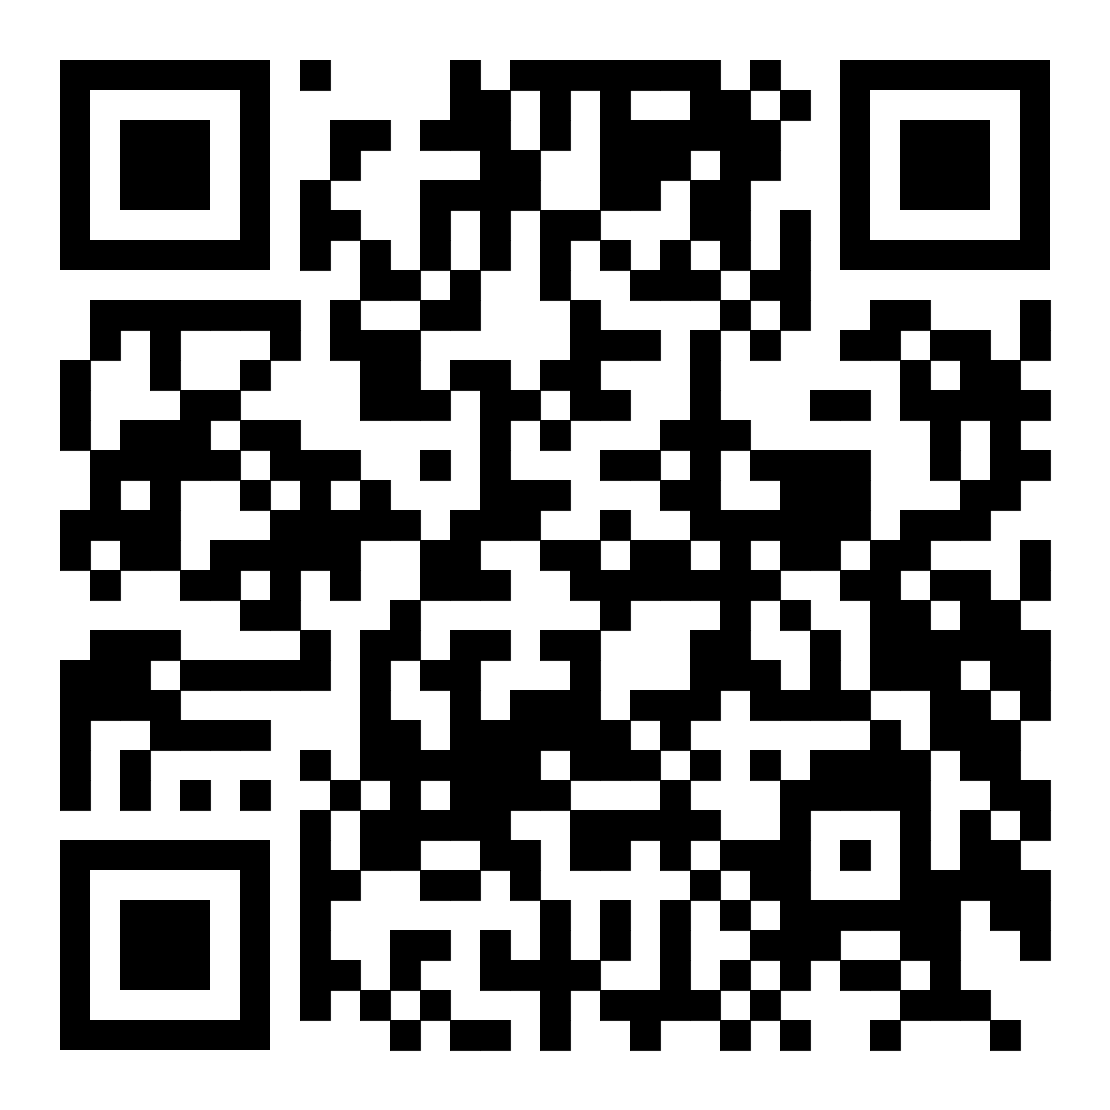

Dora Chavez Ponce

512-746-4180

[JMS/JRMS Appointment Request](https://calendar.app.google/edTowe8xFz6rHjLw6)

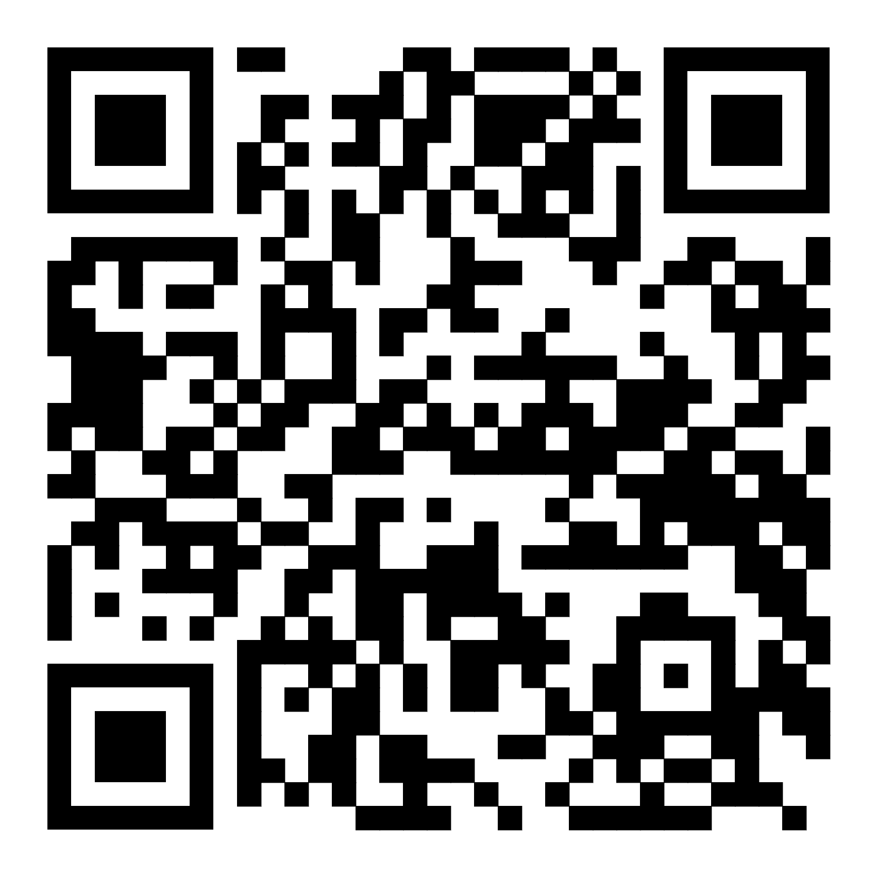

TBD

[JMS/JRMS Appointment Request](https://calendar.app.google/edTowe8xFz6rHjLw6)

Teresa Romero Kurtz

512-746-2170

[JES Appointment Request](https://calendar.app.google/sjfFmgp4TQTLc46F9)

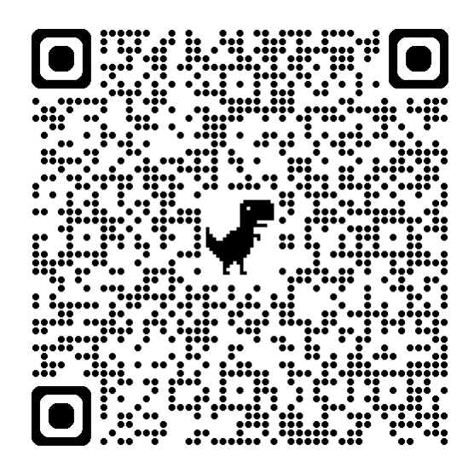

Dezurai Martinez

512-746-4805

[IES Appointment Request](https://calendar.app.google/ttJK4W7Dtj9tjHEi8)

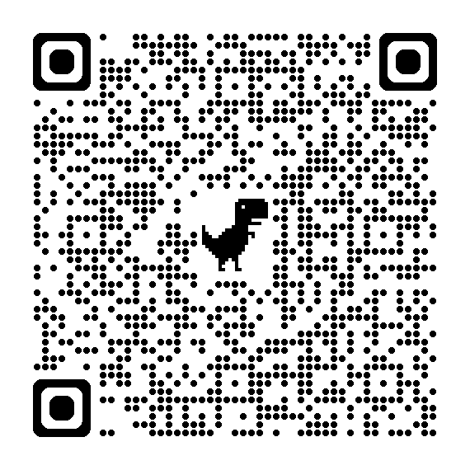

Nicole Briones

512-746-4852

[DCES Appointment Request](https://calendar.app.google/EMcMu7T5aNMEBZAE8)

